**Part 2: Design Alternatives**

**Scenario**

Scenario 1:

A mother worries about the dental health of her son and brushes it off thinking that everything is okay even though she is feeding him unhealthy food and they could not afford to visit a dentist.

Scenario 2:

Josh, a student, is having a hard time deciding whether he should go to the dentist or not. He does not want to go to the dentist unless he needs to since he does not feel any pain at all in his teeth.

Scenario 3:

A person at first had troubles with their teeth, he couldn’t afford to visit a dentist, and he was too busy. Eventually the pain went away, and he thought to himself that he was okay.

**Storyboards:**

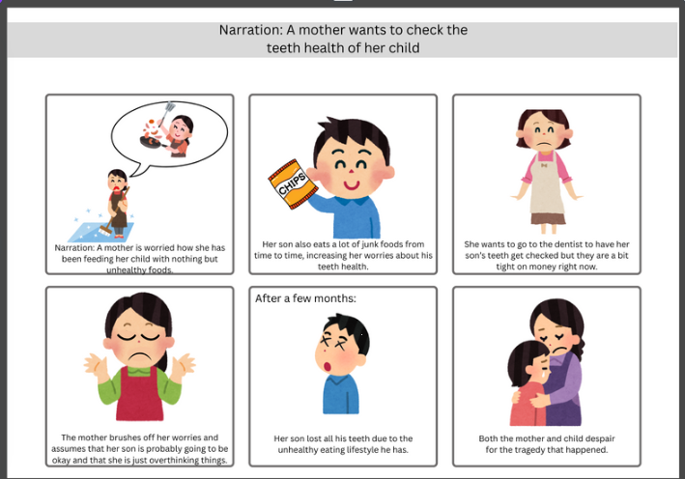**Storyboard 1 – Mother and Son**

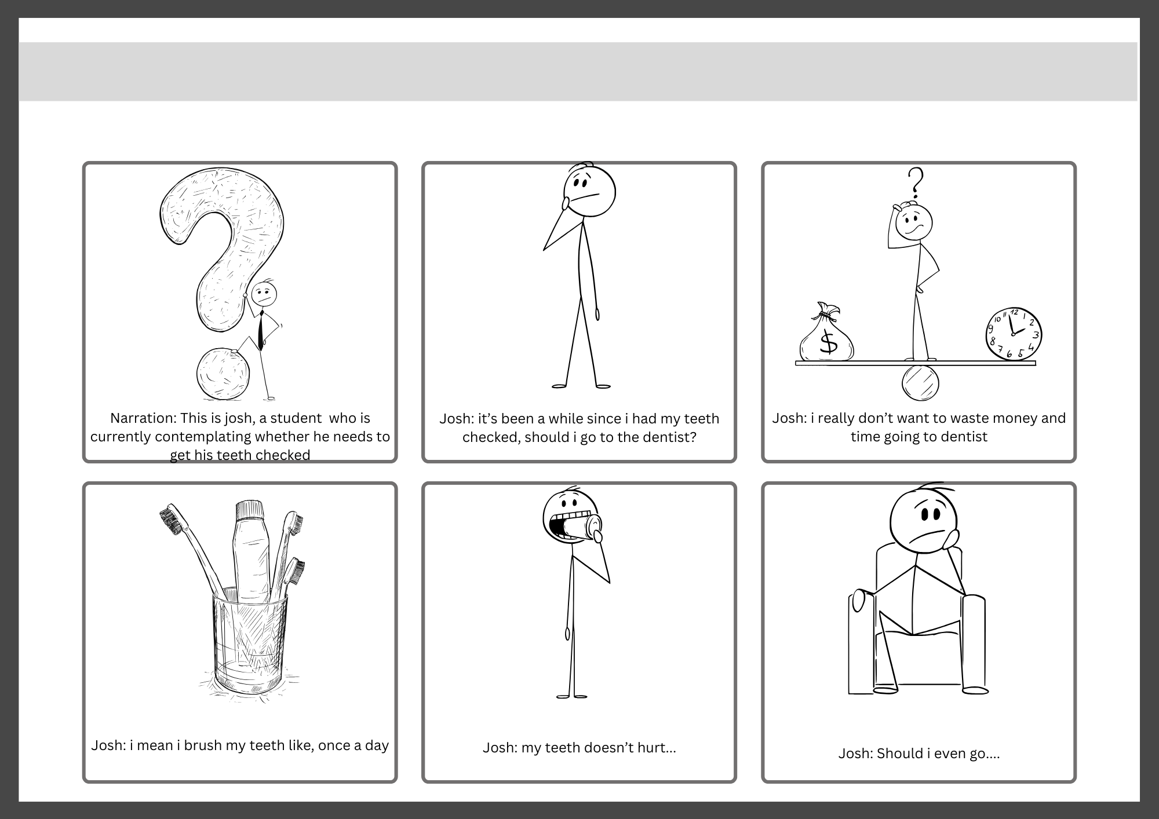**Storyboard 2 – Contemplating Josh**

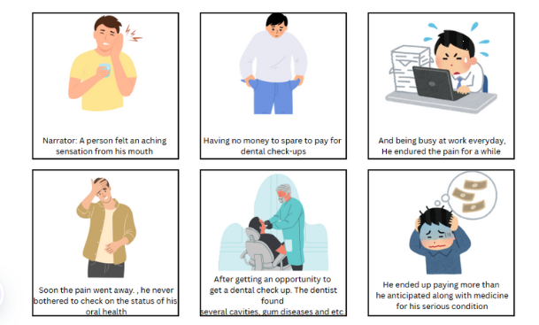

**Storyboard 3 – Busy Man**

**Problem Statement:**

* People not being able to afford a dental check up
* People hesitant in getting their teeth checked
* People being busy and can’t afford to get their teeth checked

**Application Icon Sizes**

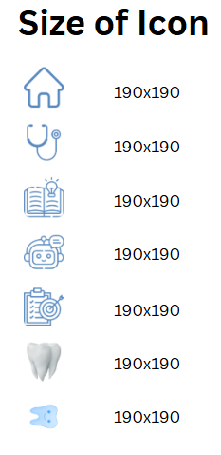

**Design**

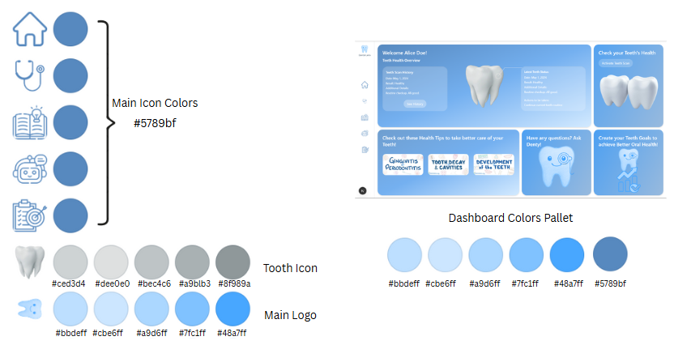

**Font Style**

Segoe UI, Roboto, sans-serif;

**GUI**

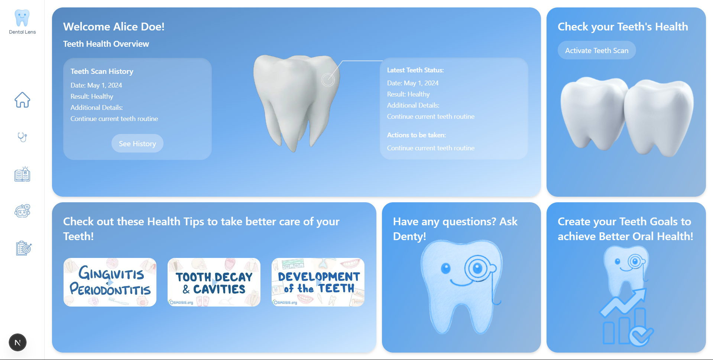

**Sample Feature Flows**

1. **Home Page is shown to users**

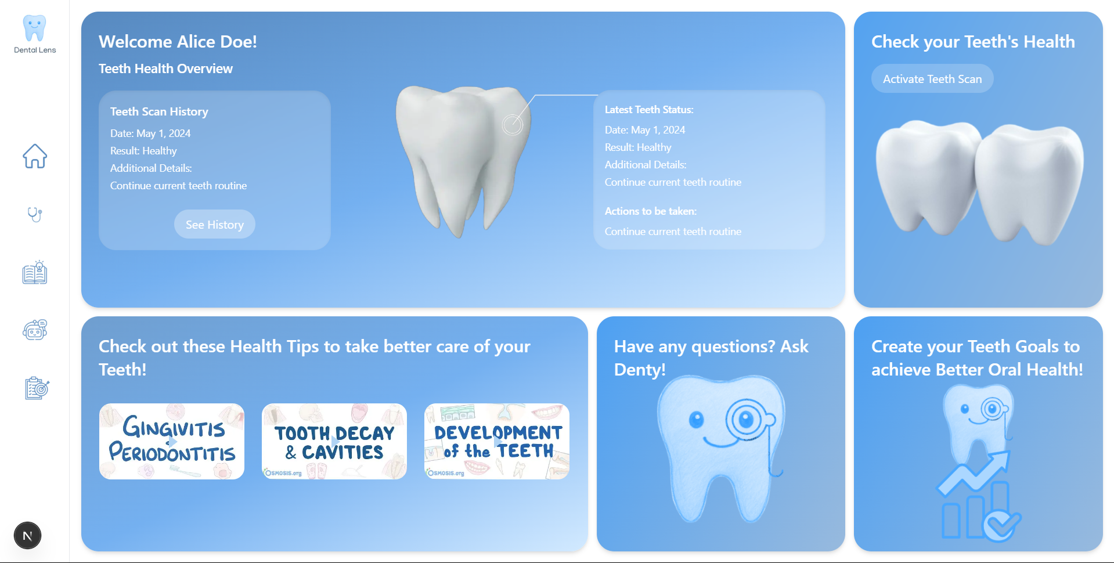

1. User presses the “Activate Teeth Scan” Page

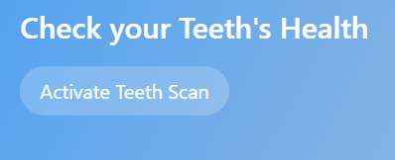

1. Users are led to the Scan Page

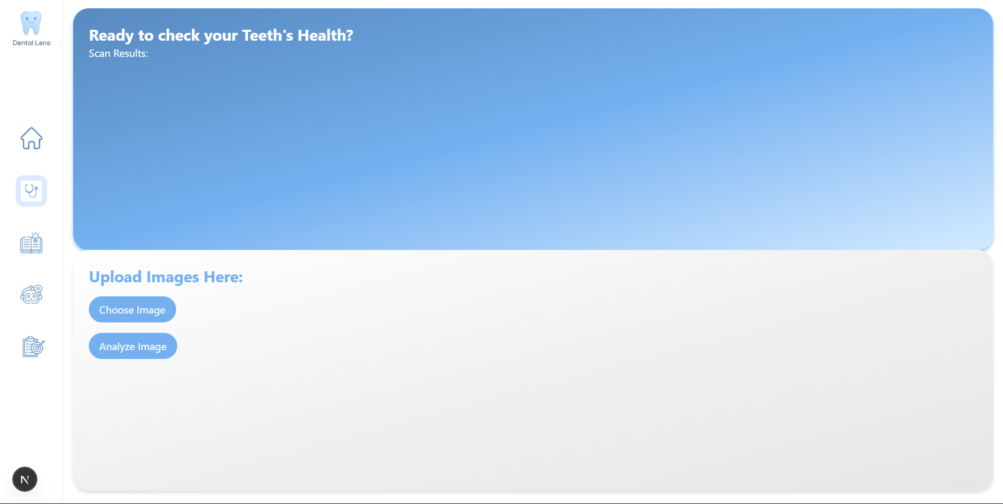

1. Users provide a teeth image

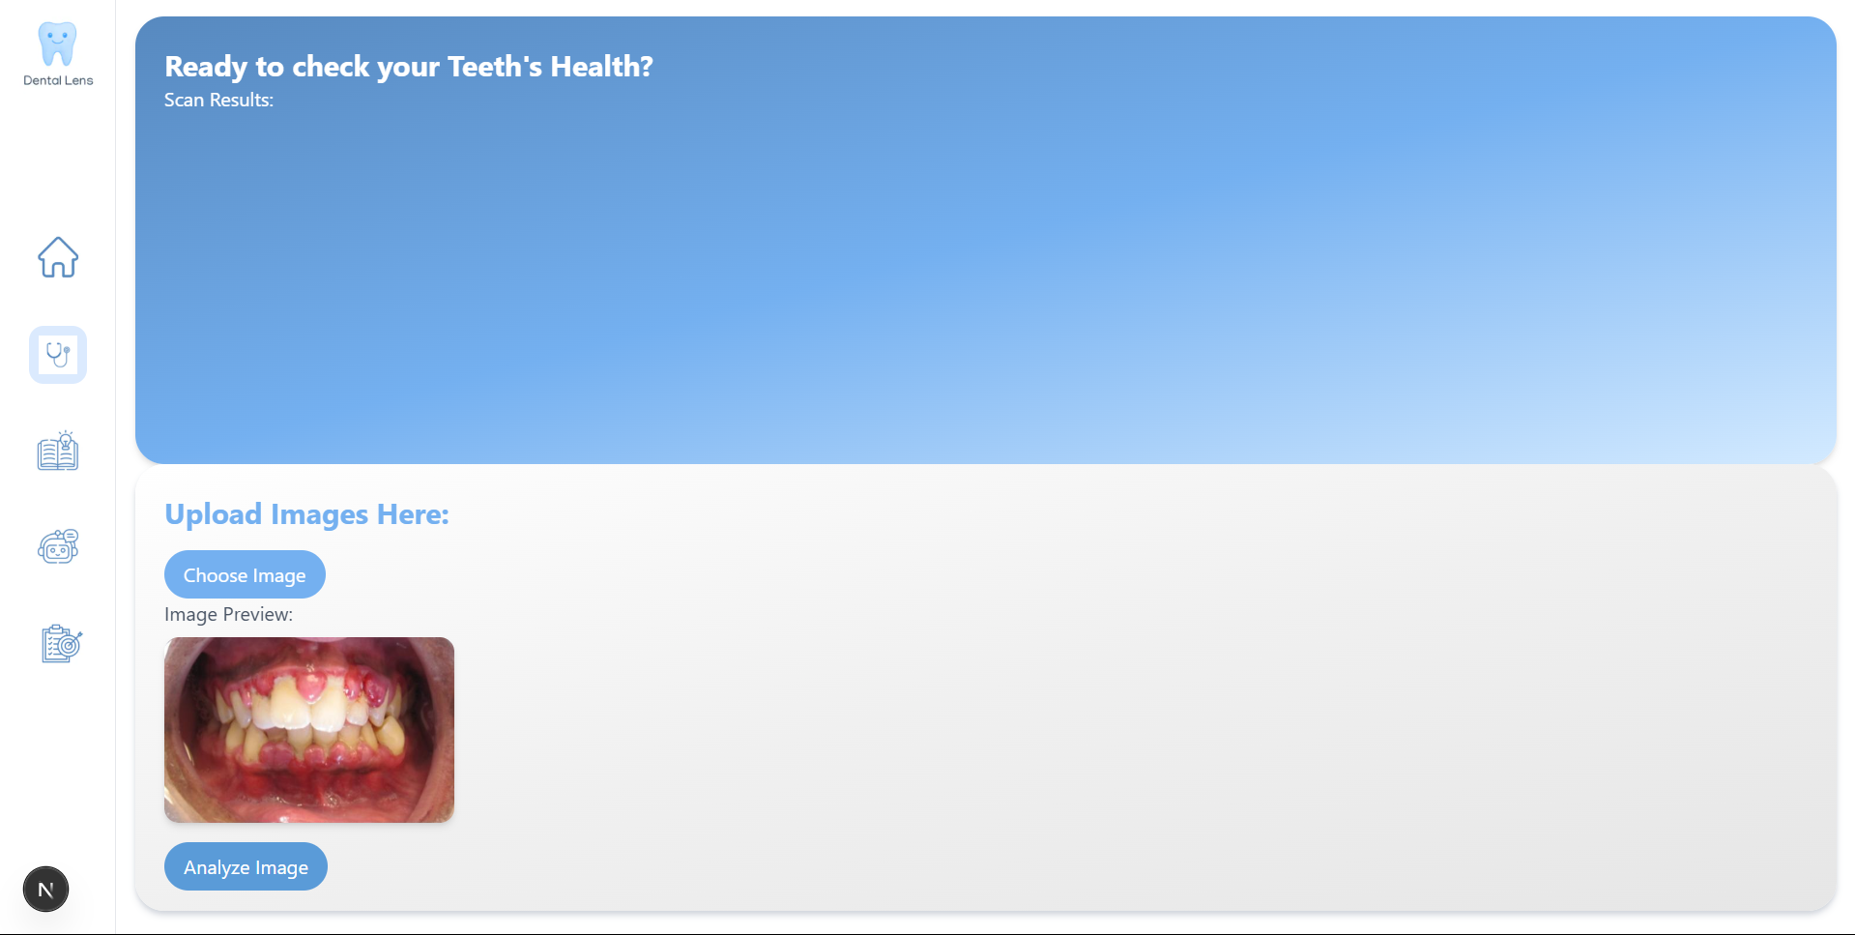

1. After pressing the “Analyze Image” button, the results show at the top

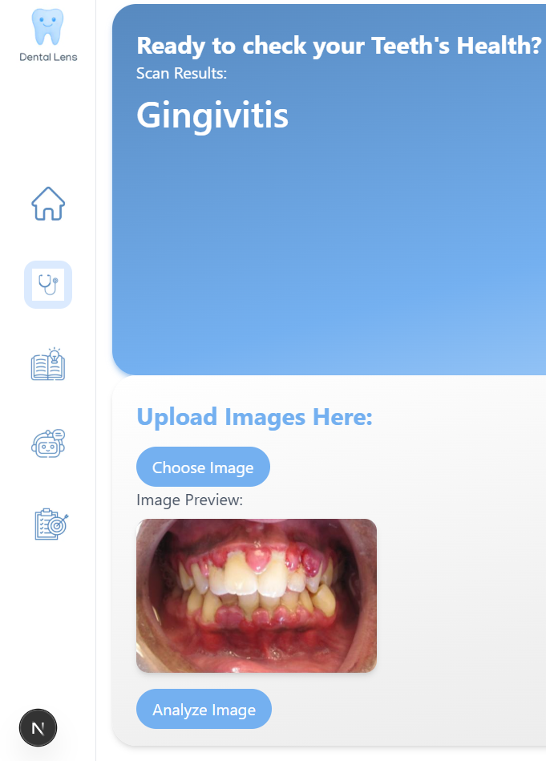

1. The results are shown on the Dashboard

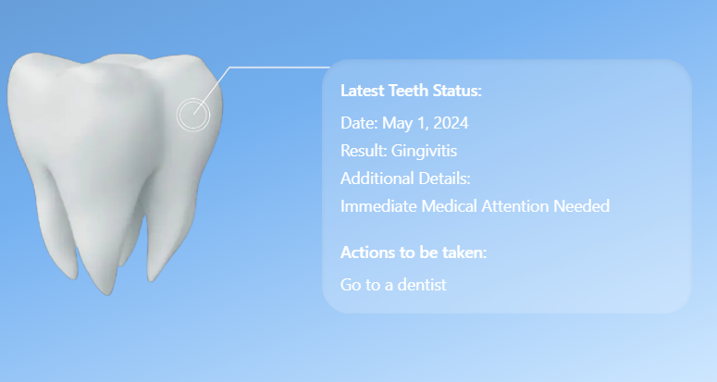

**Home Page**

The home page welcomes users and sets the tone for the entire dental care platform. It provides a clear introduction, highlighting the platform's purpose, and showing key features. With an uncluttered design and intuitive navigation, the home page helps users quickly understand where to find tools such as the scan function and educational resources.

**Scan Page**

The scan page is where users capture or upload an image of their teeth. This page guides them through the process of taking a clear photo or selecting one from their device. Once the image is submitted, the system analyzes it and updates the dashboard, providing an immediate snapshot of the user's dental status.

**Dashboard**

Serving as the central hub, the dashboard displays the latest dental analysis results. Users can view a detailed summary of their dental health, complete with visual cues and progress tracking. The dashboard also links directly to other sections, making it easy to access personalized recommendations and further insights.

**Learn Page**

On the learn page, customized educational videos and content are presented based on the latest scan results. This section is dedicated to providing practical dental care tips and deeper insights into maintaining oral health. It ensures that users receive relevant and actionable guidance tailored to their needs.

**Chatbot & Habit Tracker**

To further support users, the platform includes an interactive chatbot and a habit tracker. The chatbot offers real-time help and answers questions, ensuring users feel guided every step of the way. Meanwhile, the habit tracker helps users establish a consistent dental care routine by providing reminders and tracking daily practices.

**Design Sketches and Alternatives**

The team has created 3 different types of sketches for the website. The designs are not yet complete and will be put to the test as soon as the appropriate prototyping is completed.

**1st Sketch**

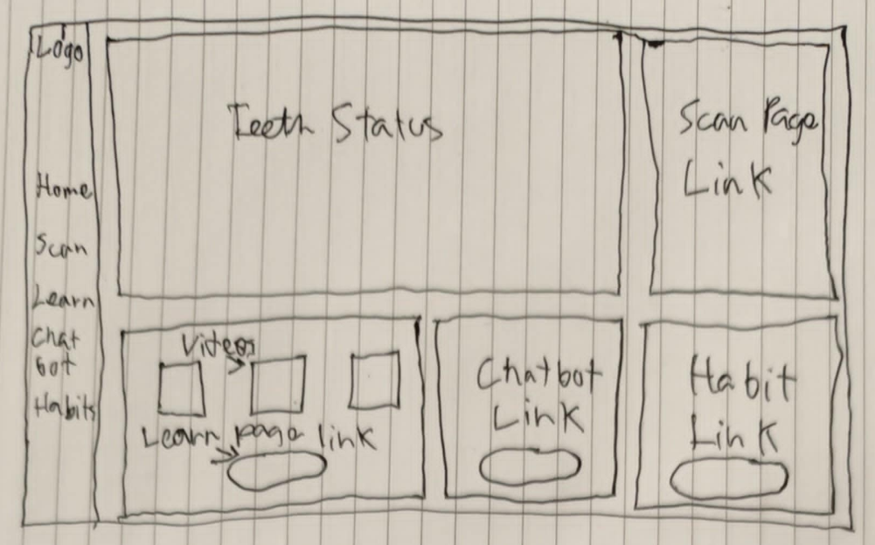The sketch shows a simple dental website that helps users take care of their teeth. The site has a few main pages, Home, Scan, Learn, Chat, and Habits. On the Scan page, users can take a photo or upload one of their teeth. The dashboard then shows the status of their teeth. The Learn page provides easy-to-understand video tips based on the scan results. The Chat tool answers any questions, and the Habit tracker helps users build good dental routines.

**2nd sketch**

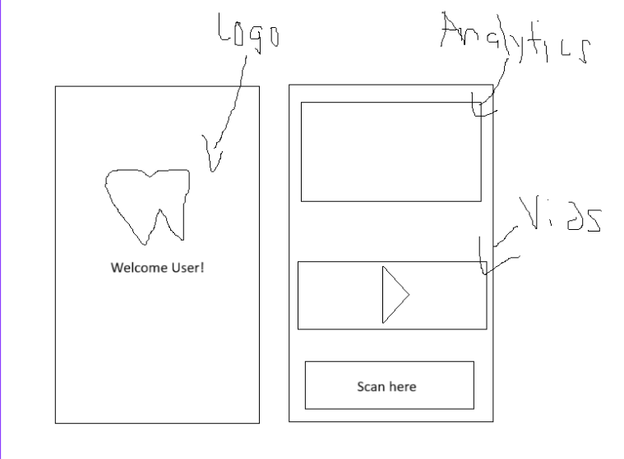This is the second sketch, which shows the mobile user interface. When the app opens, users first see the logo, creating a strong brand introduction. After that, they are taken to the main screen, where they can quickly view key analytics, watch recommended videos, and use an easy-to-spot scan button. This simple layout is designed to offer a fast, clear, and efficient experience right from the start.

**3rd sketch**

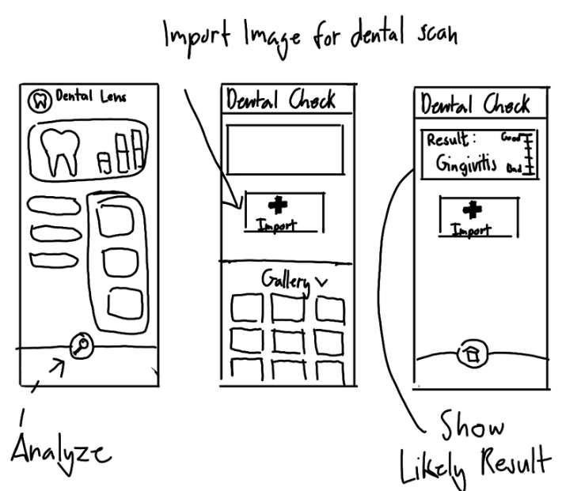

This is the third sketch, showing a hand-drawn layout for the dental health app. In this design, a horizontal navigation bar runs along the left side, listing the Logo, Home, Scan, Learn, Chatbot, and Habit options. The main area is divided into a few sections: a prominent "Teeth Status" panel at the top that displays the current dental analysis, a nearby link to the Scan page, and three buttons below for Videos (linking to the Learn section), Chatbot, and Habit tracking.

**Mock-up/Prototype**

